Week 8 Assignment - Practice *Faithfulness* with multiple scenarios (including the shared examples).

*Scenario 1*
Metrics- Faithfulness
Input (User question):What is selenium
Actual output (Models Actual output):Selenium is a web automation framework for testing web application
Retrieval context -Selenium is a web automation framework for testing web application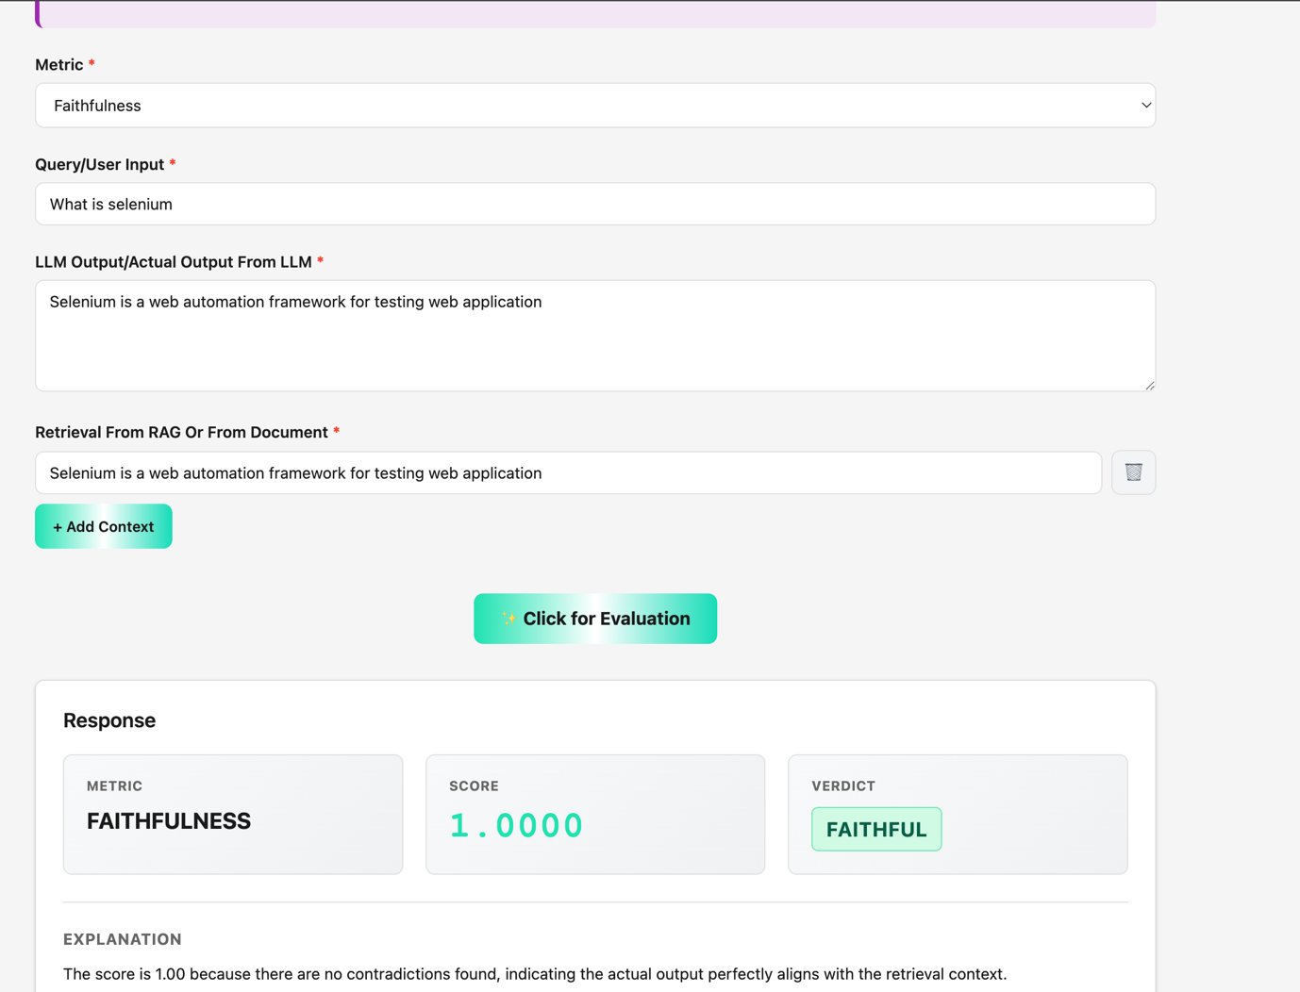

*Scenario 2*
Metrics-Faithfulness
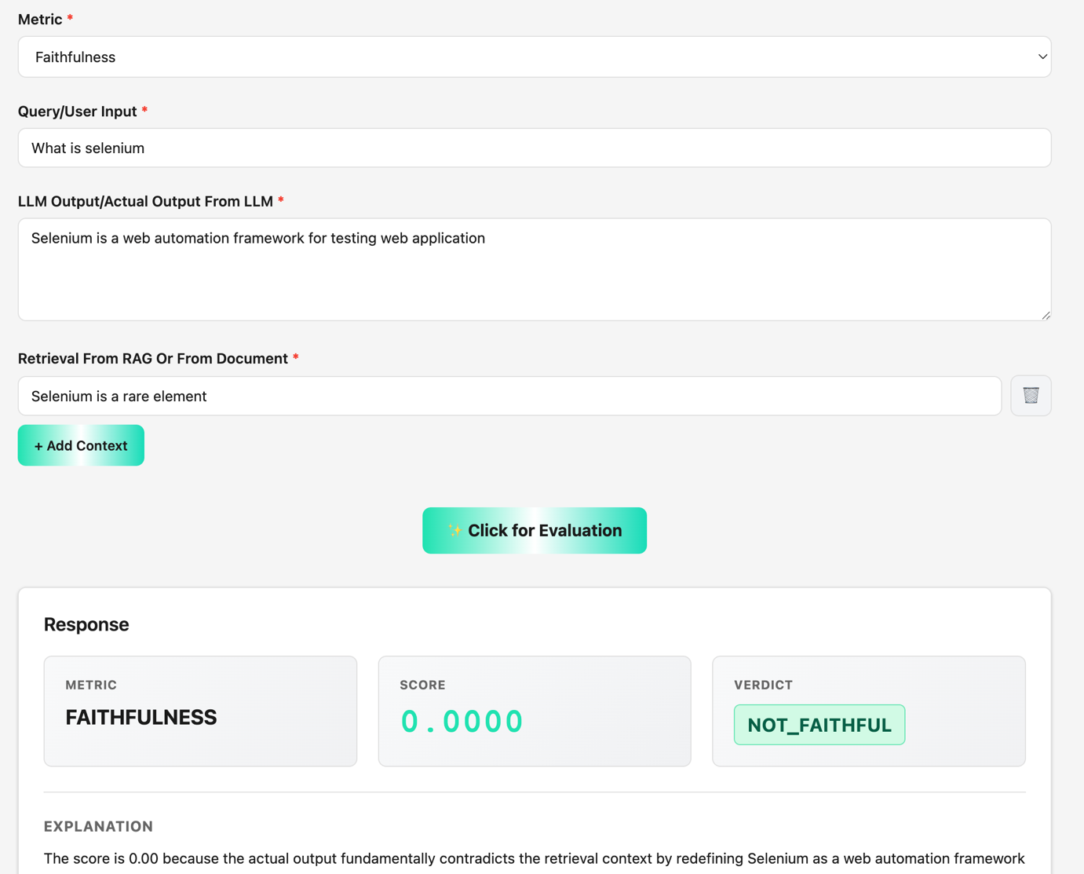

Input: What is selenium
Actual output: Selenium is a web automation framework for testing web application
Retrieval context: Selenium is a rare element

*Scenario 3*
Metrics-Faithfulness
Input (User question):What is selenium
Actual output (Models Actual output):Selenium is a automation framework for testing web and desktop application
Retrieval context -Selenium is a web automation framework for testing web application(From Mongo)
